STOCKLOT OF RECYCLE NAPKIN PAPER
*This lot was made for Mexican market originally.
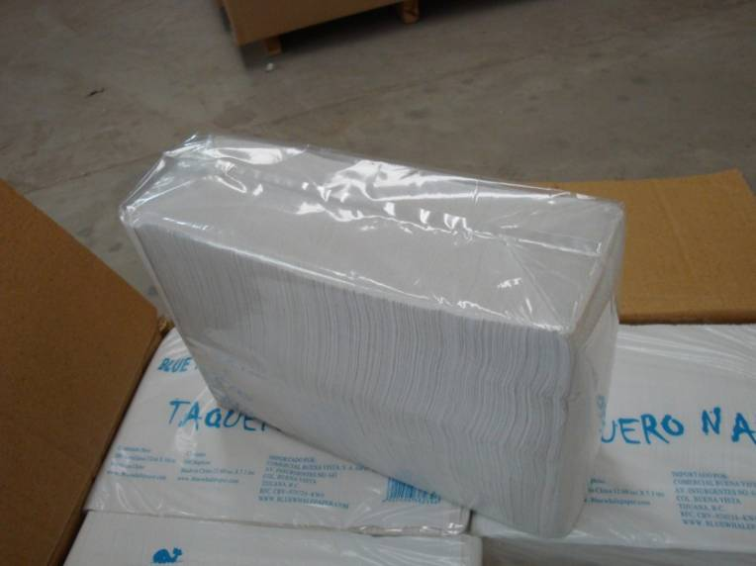 | 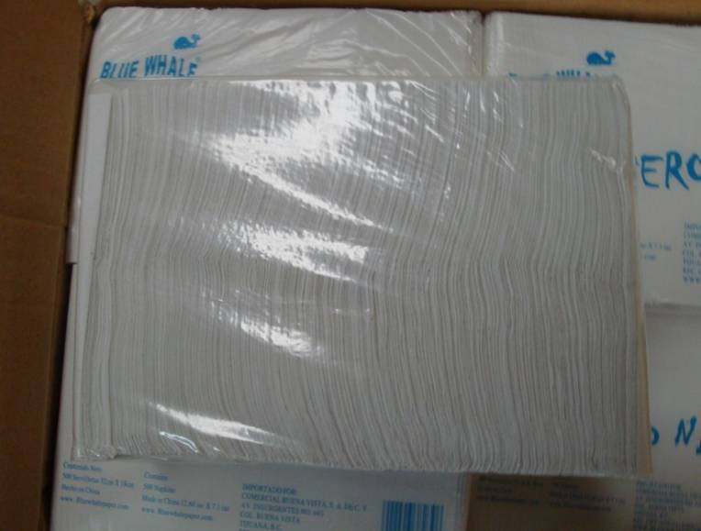
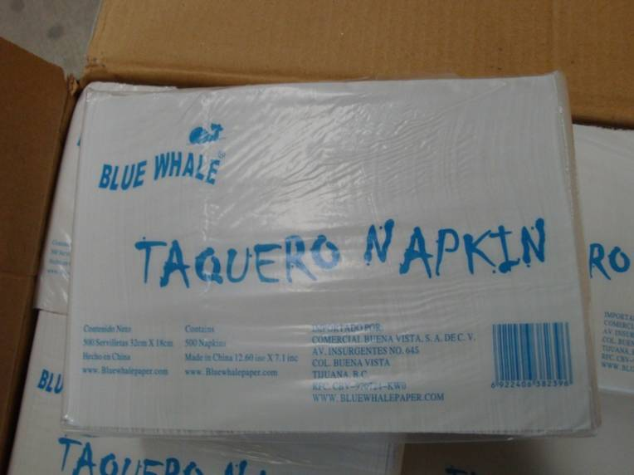 | 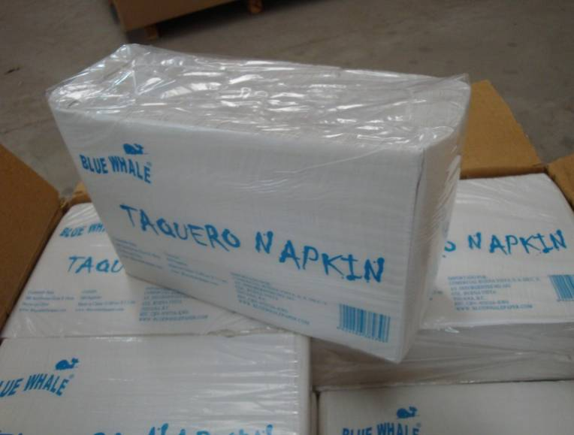
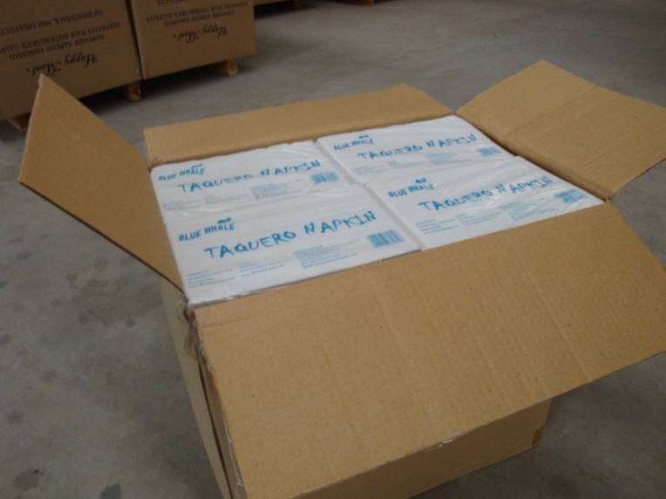 | 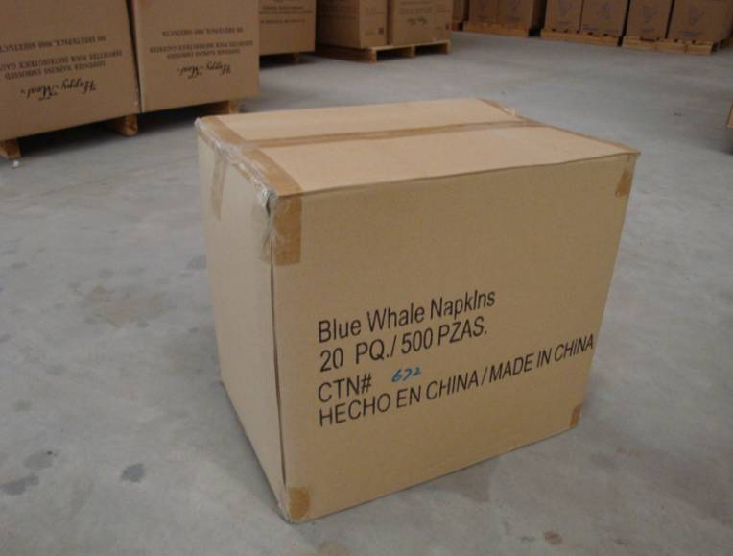
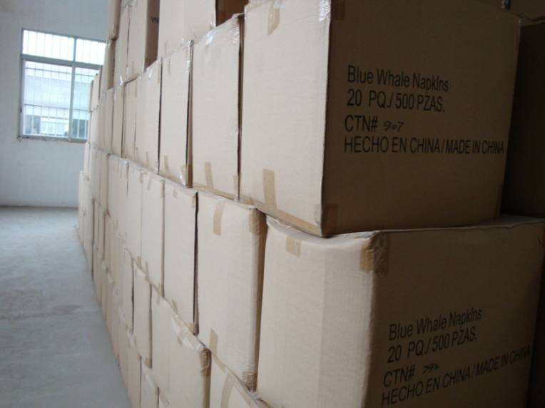 | P100415 RECYCLE NAPKIN PAPER- made from recycle materials, size: 33x17 cm. 500 pcs per bag (pack), 20 bags packed in a carton (2.5 cuft./0.071 cbm).  Q‘ty: 26,000 bags (1,300 ctns)  FOB US$0.68/bag

